**REGISTER/LOGIN MANAGEMENT USING OPENCV**

Project submitted to the

SRM University – AP, Andhra Pradesh

for the partial fulfilment of the requirements to award the degree of

**Bachelor of Technology/Master of Technology**

In

**Computer Science and Engineering**

**School of Engineering and Sciences**

**Submitted by**

**SRINIVAS PRADHAN - AP21110010220**



Under the Guidance of

**Kavitha Rani**

**SRM University–AP**

**Neerukonda, Mangalagiri, Guntur**

**Andhra Pradesh – 522 240**

# Certificate

Date:05/12/22

This is to certify that the work present in this Project entitled “**REGISTER/LOGIN MANAGEMENT USING OPENCV**” has been carried out by **SRINIVAS PRADHAN(AP21110010220),** under my/our supervision. The work is genuine, original, and suitable for submission to the SRM University – AP for the award of Bachelor of Technology/Master of Technology in **School of Engineering and Sciences**.

## Supervisor

(Signature)

Prof. / Dr. Kavitha Rani

Designation,

Affiliation.

## Co-supervisor

(Signature)

Prof. / Dr. [Name]

Designation,

Affiliation.

**Table of Contents**

Certificate

Table of contents

Abstract

Introduction

Discussion

Conclusion

# Abstract

* Register and Login Management using OpenCV is basically a idea of login interface using image of respective person.
* Registering an username with an image which will be stored in the database and while login the login interface checks the image of respective username-holder and the image stored with the username.
* Then allows the user to login if the image verification fails Image verification failed will be displayed on the login interface.

# Introduction

* As the name suggests, “Register/Login Management using OpenCV” is centered around Register and Login management.
* The goal of this article is to provide an easier human-machine interaction routine when user authentication is needed through face detection and recognition.
* The user enters username and password but our project uses OpenCV – Face Detection, which quantifies the face into an array of 128 numbers.
* The face is scanned when registered and compared during logging in.
* After logging in , the user can create , edit and delete files.

In the source-code we used imported different kinds of modules like

* tkinter,SQLite3,cv2,numpy,face_recognition etc.
* Tkinter - Graphical User Interface(GUI).
* SQLite3 – Develop embedded software for camera.
* Cv2 – Display an image in a window.
* NumPy – Working with arrays.
* face recognition – Detect faces in an image

CODE:-

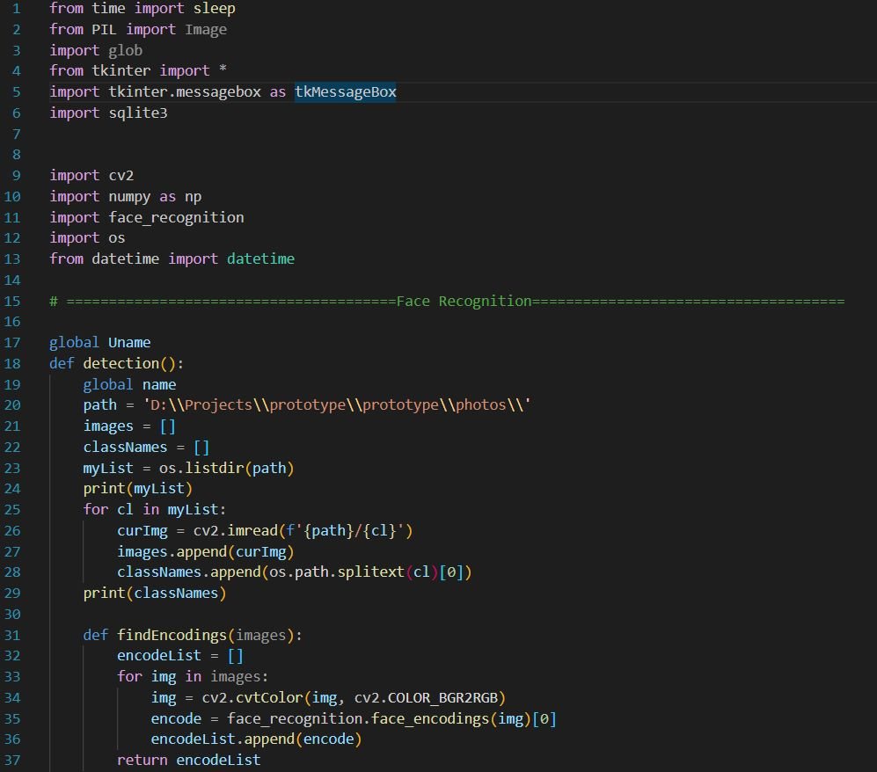

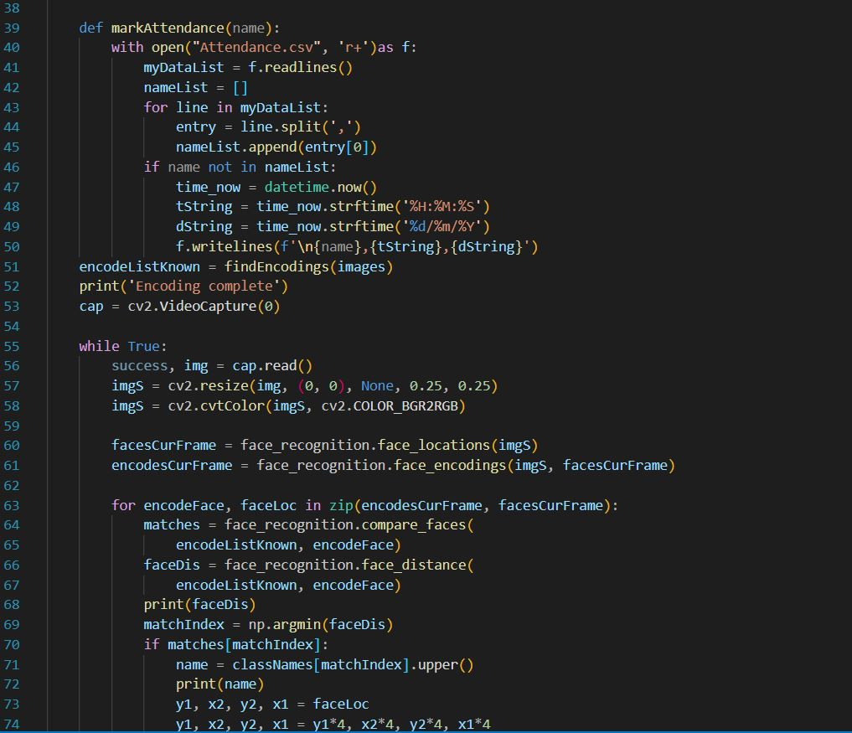

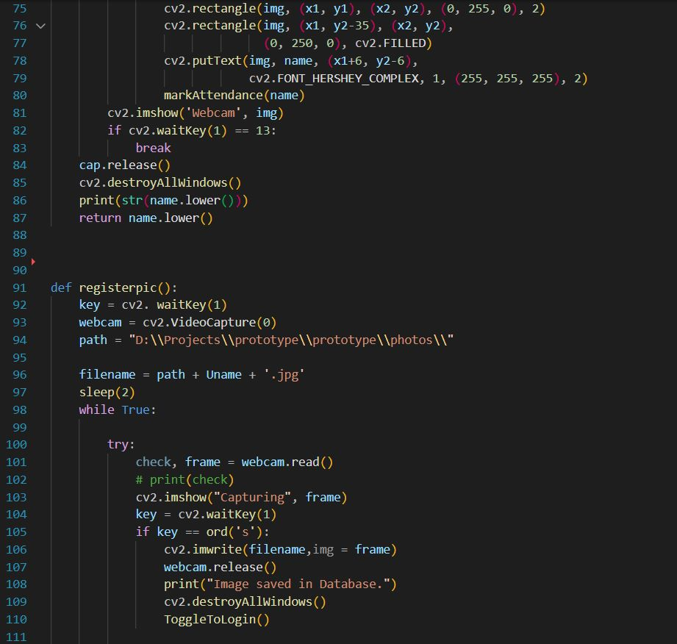

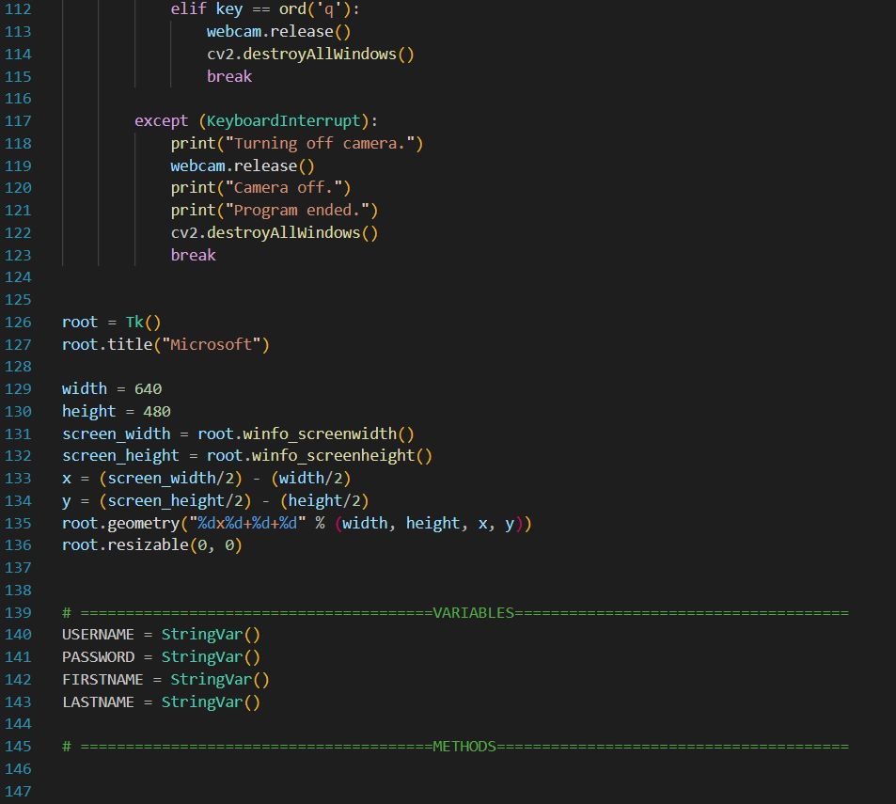

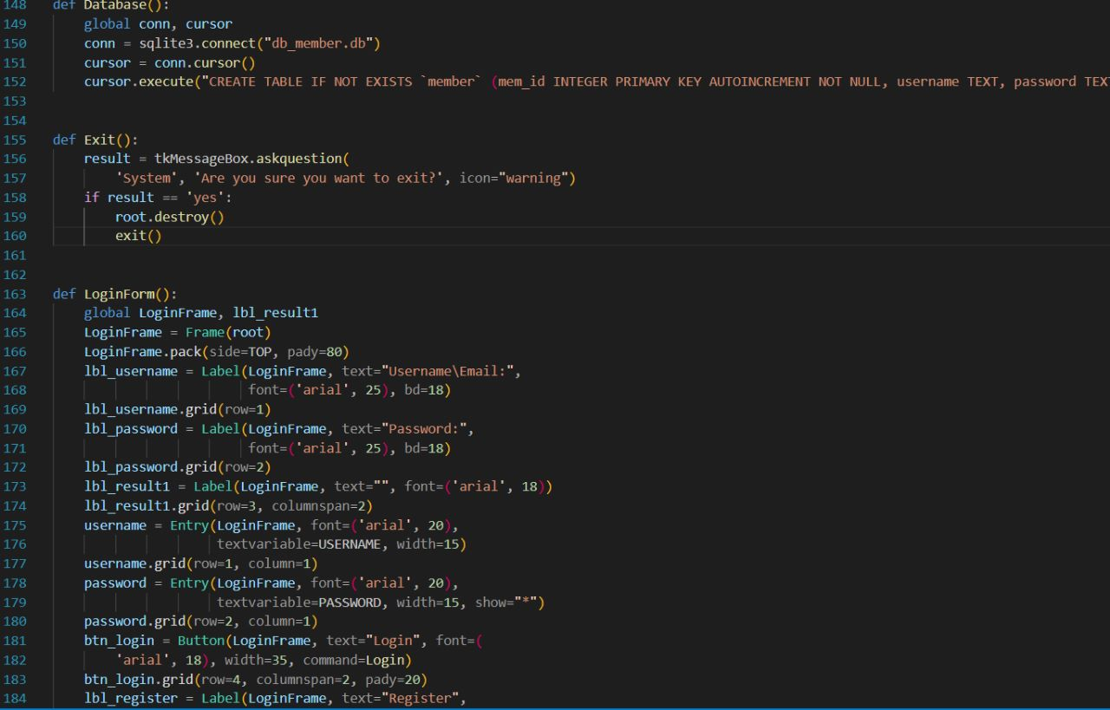

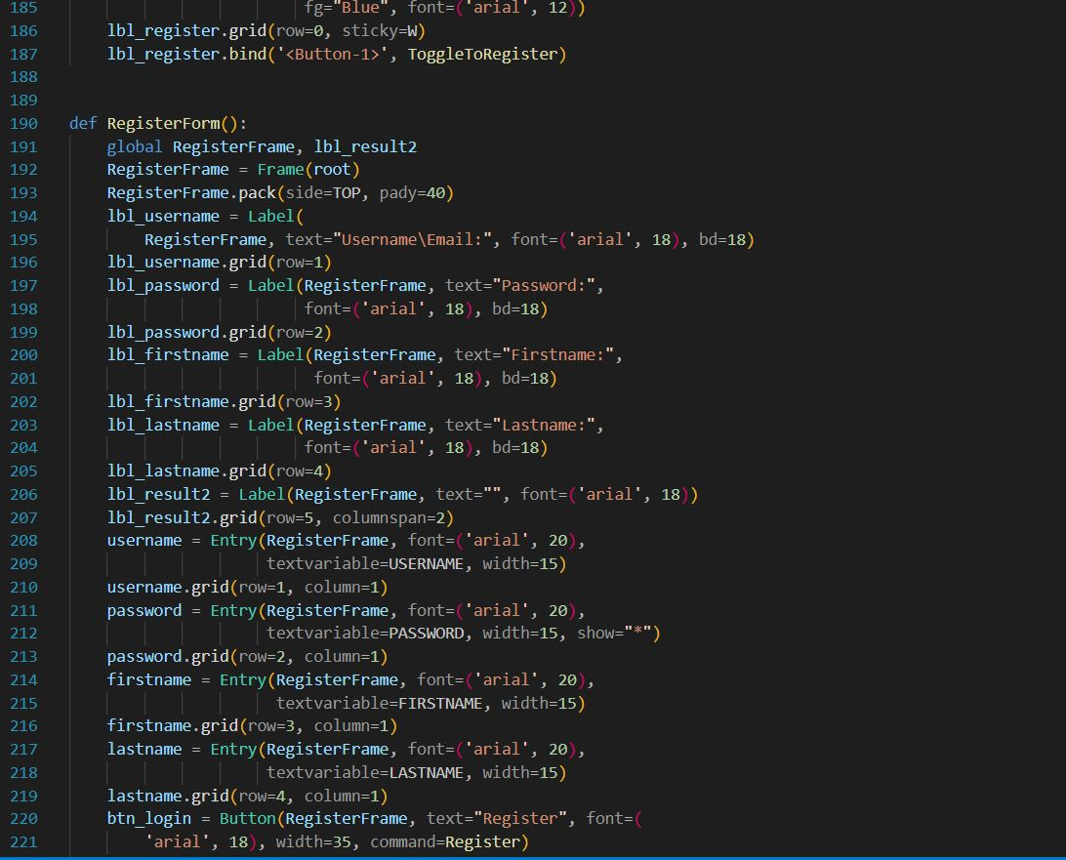

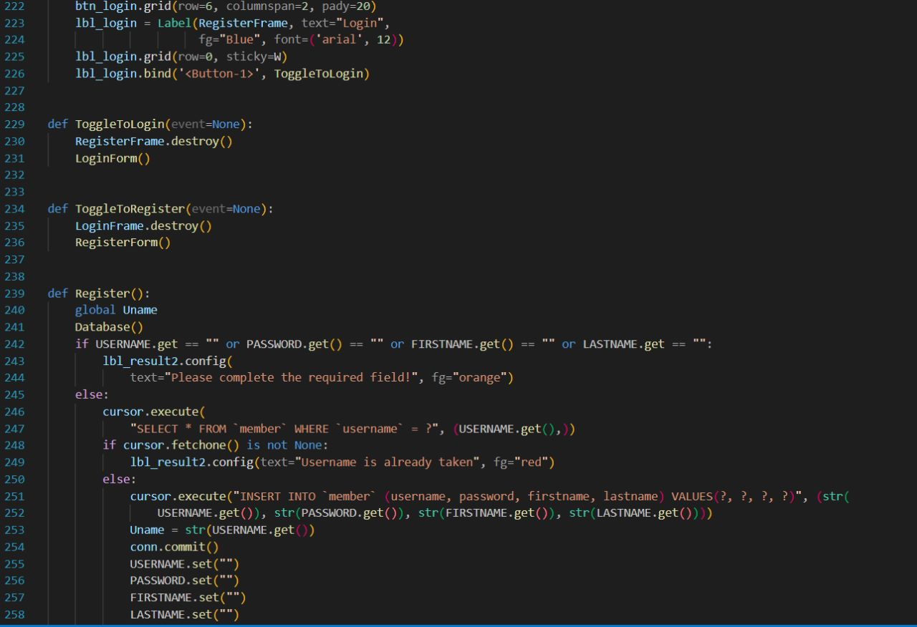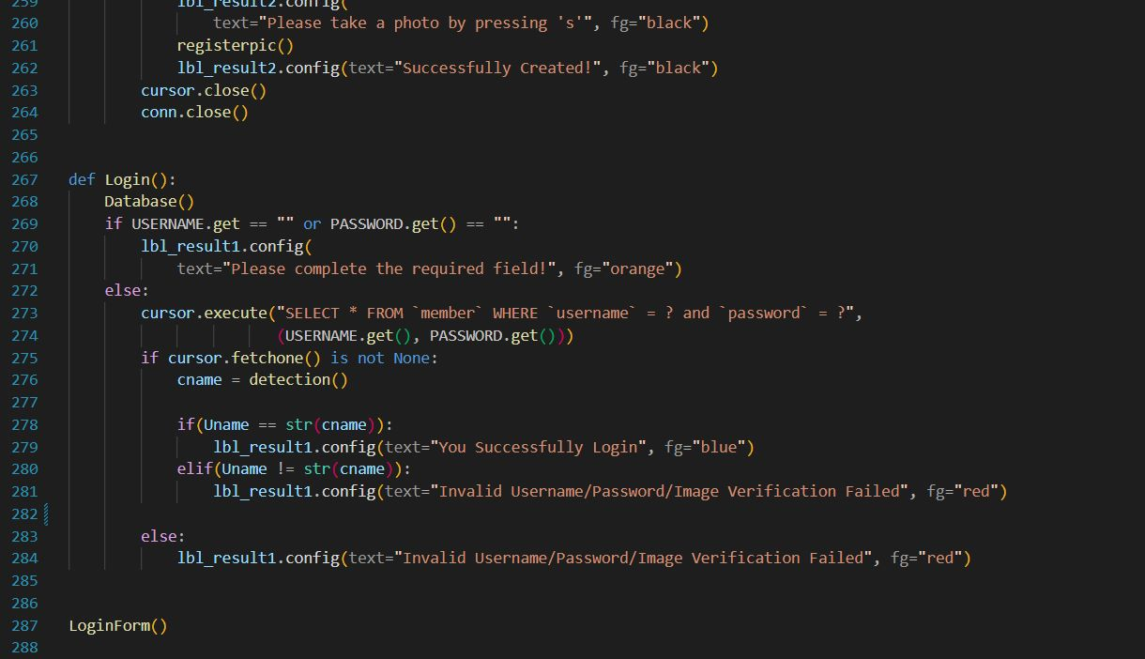

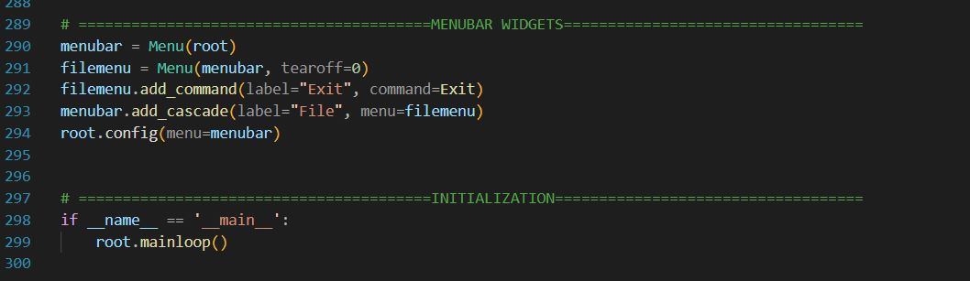

**Discussion**

* Code basically runs with specific modules it takes the registration details and takes the image of the user then saves the image in the database.
* Login with the credentials given at the time of registration and click on login.
* Webcam captures the image and verifies the username and image of the webcam captured image captured while login
* If the image is same then it shows login successful
* If the image or username doesn’t match then shows image verification failed.

**Conclusion**

* Face recognition is used widely across the world for security .
* Logging in through ones face can add more security to the personal files or accounts.
* This can be used in any login based portals or files or accounts which helps the user to secure their things.
* This inference is mainly seen in mobile phone face unlocking system, Aadhar iris verification etc.